The 12th European
Urban and Regional Planning Awards
2017-2018

Project Submission Form

Airports, Cities and urban development

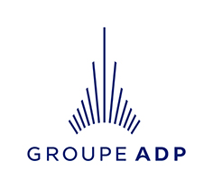
The 12th European Urban and Regional Planning Awards 2017-2018 Submission Form
The Awards are open to spatial planners and municipalities from the 47 European Countries of the Council of Europe.
Please complete this form and send it with your entry to ECTP-CEU:
Secretariat@ectp-ceu.eu before the 31th March 2018
Entry Requirements:

Each entry should include:
- A detailed written description of the entry in English and in French. The description must be no longer than four A4 pages (in each language) including the title, tables and references.
- A high resolution version of a colour panel in 80 X 150 cm format (80cm wide, 150cm high), providing a clear explanation, detailed location and detailed illustrations in English. The high-resolution file is needed to print on rollups and serve for the jury and the exhibitions that will then be organized with the Metropoli Foundation, the ADP Group and the Committee of the Regions.
The sent file will be:
- in jpg, tiff or pdf
- in CMYK (CMJN)
- minimum 150 ppi, preferably 300 ppi.
- Be careful not to use too small text.

- All material (electronic versions of the panel, the written descriptions, all info) should be placed in a downloadable zip file and the web address (url) provided at submission. Sending by ‘wetransfer’ is also accepted.
- The Submission Form, containing:
  - All project information
  - A named contact (with contact details) for the planners - the team or the team leader - responsible for the planning input into the selected project; a named contact for the local authority or agency which financed/commissioned the work; and the name of the chief officer (eg chief executive or mayor) and the chief planning officer
  - A summary expert CV
  - A summary description of the project
  - Information about any young planners (aged 37 or less) who were involved
- The bank evidence of the payment of the entry fees.

General Information
Full title of project:
! this title will be used in all communications !

Name of Planner/s responsible for the planning input into the project:
Name of Planner/s
Company/organisation/institution/
Address
Phone/fax
E-mail

Location of the project:
Country/state/region/town
Population (if known)
Size of the area concerned (in ha):

Local authority or agency in whose name the entry is made and name of the Mayor or President of Region:
Mayor or President of Region:
Company/organisation/
institution/administration
Address
Country/state/town
Name of contact person
Phone/fax
E-mail

Degree of implementation - please insert dates as appropriate:
Research / Project approved
Implementation planning
Project completed

Please indicate the scale of the project (local - regional - interregional - national).

Extra comments (not mandatory)

Comments of the association of spatial planners from your country: (If the project is recommended by them)
Name of the association:

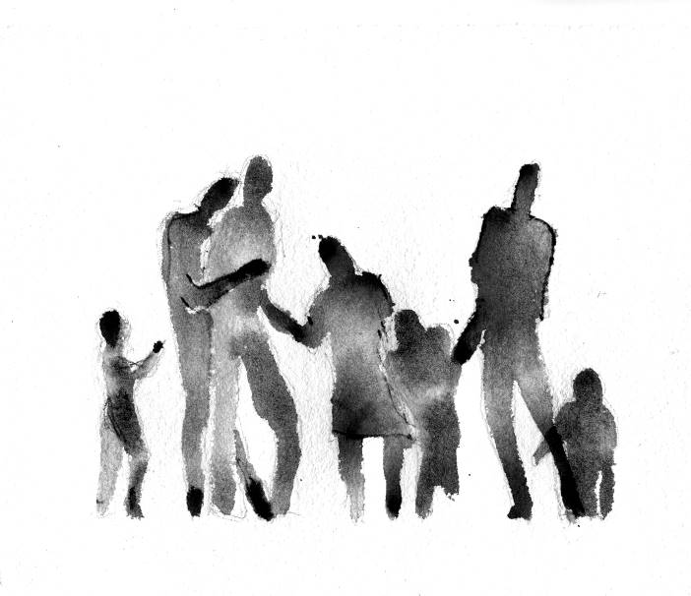

expert profile CV

Field | Content
Name of the expert
Photo
Areas of expertise | Highlight here the areas of expertise  - Buildings  - Environment  - Culture and Education  - Energy  - ICT and Smart Cities  - Industry and Trade  - Urban Planning  - Transport  - Water  - Waste
Golden paragraph | (short description / cv of the expert)
Contact details
Languages
Attached document
Link to external profiles
Related city

BEST PRACTICE/ Project/ PROFILE

Field | Content
Name of the project
Name of the city
Image illustrating the project
Theme category | Select out of the following 10:  Buildings  Environment  Culture and Education  Energy  ICT and Smart Cities  Industry and Trade  Urban Planning  Transport  Water  Waste
Summary information | Description of the project (150-200 words max.)
Contact person
Website link
Factual information (if applicable) | Foreseen/Available budget for this project
Factual information (if applicable) | Funding sources
Factual information (if applicable) | Duration of implementation of the best practice
Factual information (if applicable) | Impact (social, environmental, technical, etc.)  Urban perception  Mobility  Greening and public spaces  Public facilities  Environmental impact
Key words | Identify specific key words outlining the best project  Urbanism  Urban planning  Urban design  Sustainable design  Singular projects  Greening  Rehabilitation  Cultural promotion  City  Governance

Deadline:

All entries must be received by March 31st 2018.

Entry Fee:

The Entry fee to the 11th European Urban and Regional Planning Awards varies depending if it is sent directly or if it is endorsed by an ECTP-CEU member (national spatial planner association).

If sent directly: 500,00 €
If endorsed by an ECTP-CEU member: 250,00 €

The endorsement by the ECTP-CEU member (national spatial planner association) can be stipulated on this form or confirmed by email exchange.

The payment should be made by bank transfer to:

Bank Name: ING Banque
Account number (IBAN): BE56 3100 0708 1288
Account name: Conseil Européen des Urbanistes
BIC code: BBRUBEBB

The Awards / prizes
ECTP-CEU will present Certificates of Achievement to the winners. Awards will be given to those entries considered outstanding according to the assessment criteria. The Awards will be made to the authority or body responsible for the commissioning or production of the scheme and to the professional planners involved.
The ECTP-CEU will distribute a prize of 5000 € to the best projects presented.
The official Awards Ceremony will take place on May 18, 2018 at Roissy Charles de Gaulle's Maison de l’Environnement et du Développement durable.
A presentation will be organized on 25 September 2018 at the Committee of the Regions in Brussels. The ECTP-CEU, the Committee of the Regions, the Metropoli Foundation, the ADP Group will ensure wide media coverage of this event and its laureates.
A specific publication will be disseminated on the 12th European Urban and Regional Planning Awards.
Each laureate will benefit from a publication of the project in the newsletter of the Committee of the Regions.
The ownership of the results remains exclusively ECTP-CEU’s and the dissemination of the results will be exclusively managed by the Executive Committee of the ECTP-CEU.
Further Information
For further information about past awards, and for nomination forms, please contact the national spatial planning organisations that are members of ECTP-CEU.
Addresses to be found at: www.ectp-ceu.eu
ECTP-CEU e-mail: secretariat@ectp-ceu.eu

The European Urban and Regional Planning Awards
Are proposed and organised by the ECTP-CEU
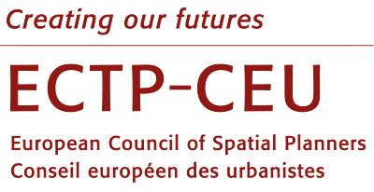
This 12th edition has the support of
  Metropoli Foundation | ADP Group | 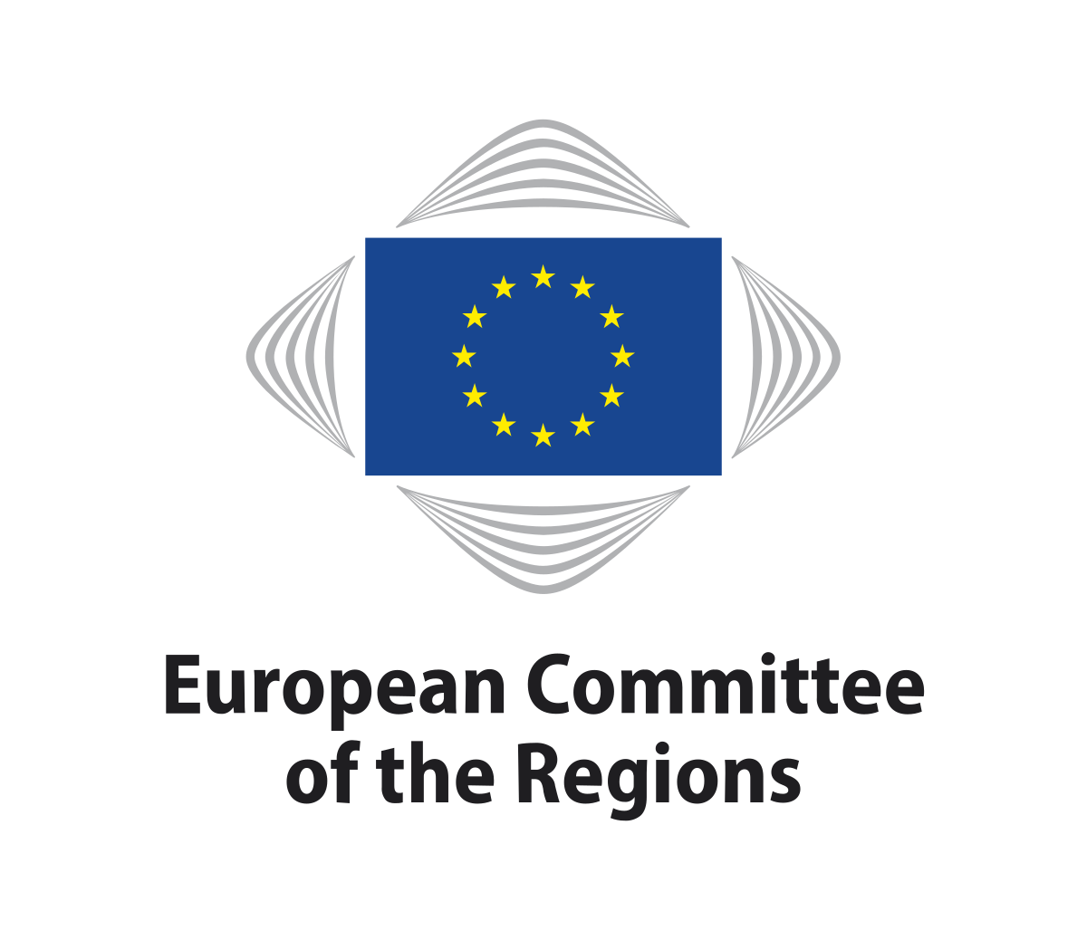  Committee of the Regions

